Nama : Asri Nihal Salsabila

NIM : 18090087

Kelas : 5C

1. URL : <http://localhost/web2/index.php/Matakuliah>
2. Source Code

* application 🡪 controller 🡪 Matakuliah.php

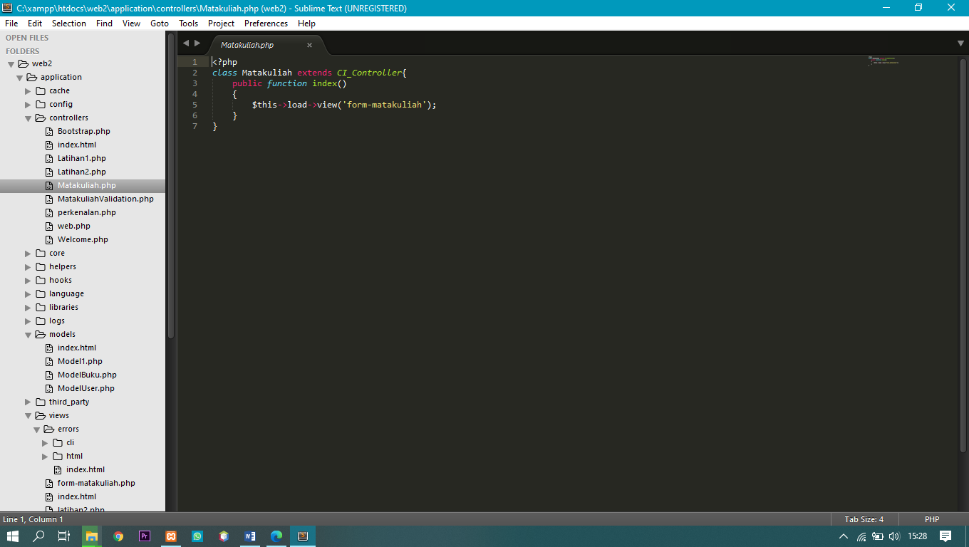

* application 🡪 views 🡪 form-matakuliah.php

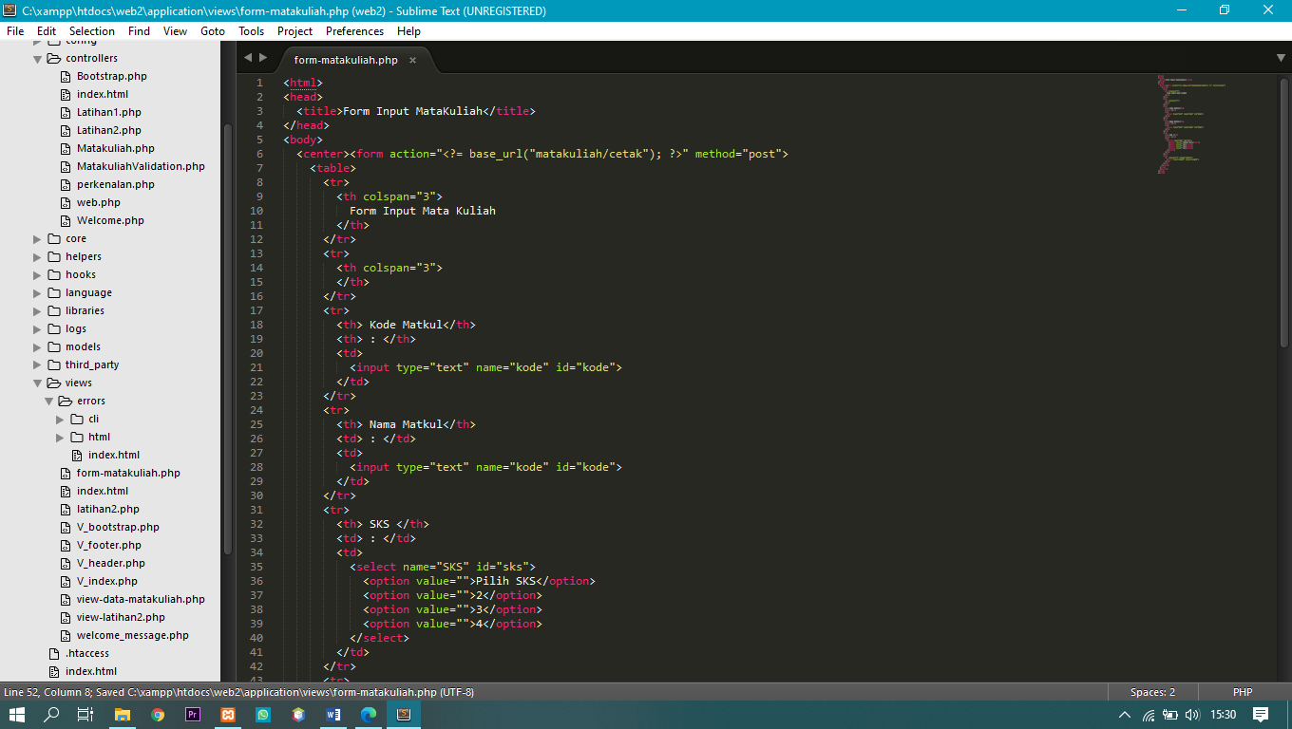

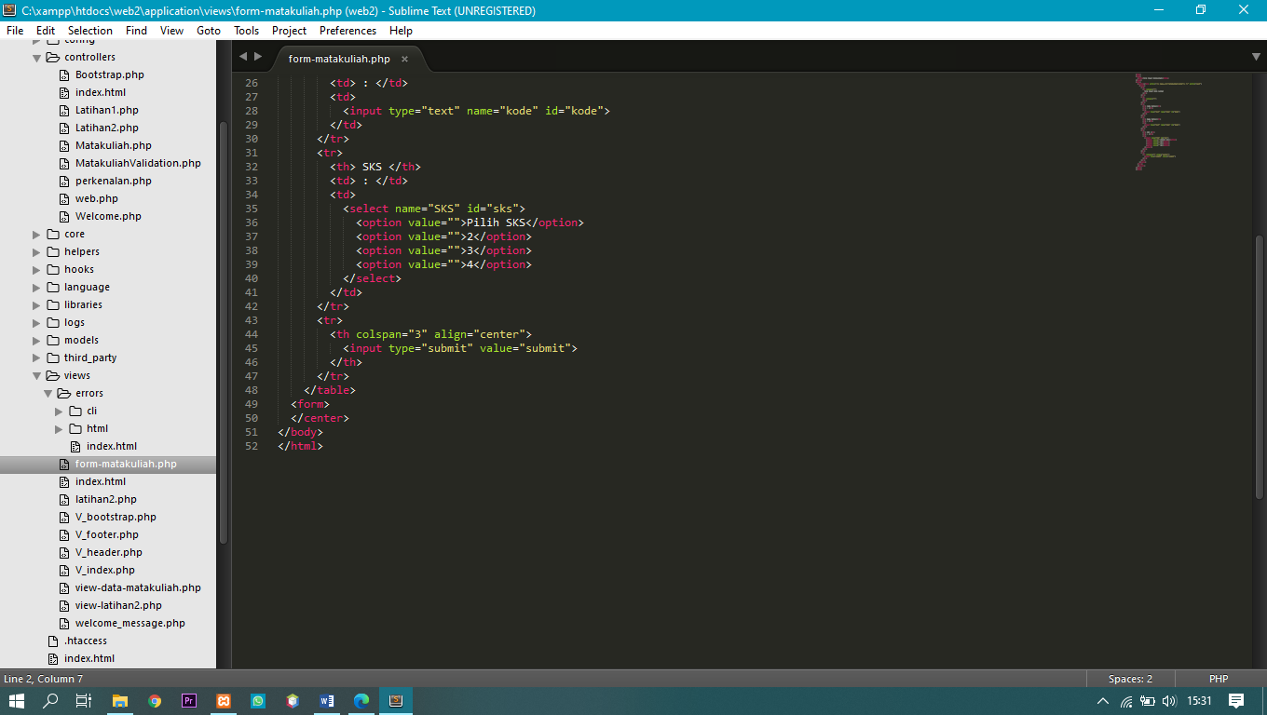

* application 🡪 views 🡪 view-data-matakuliah.php

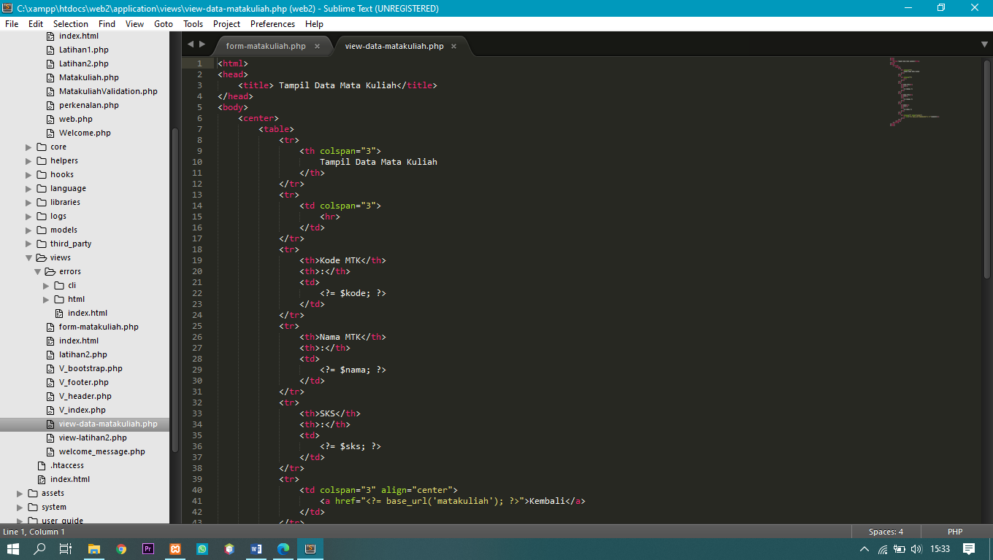

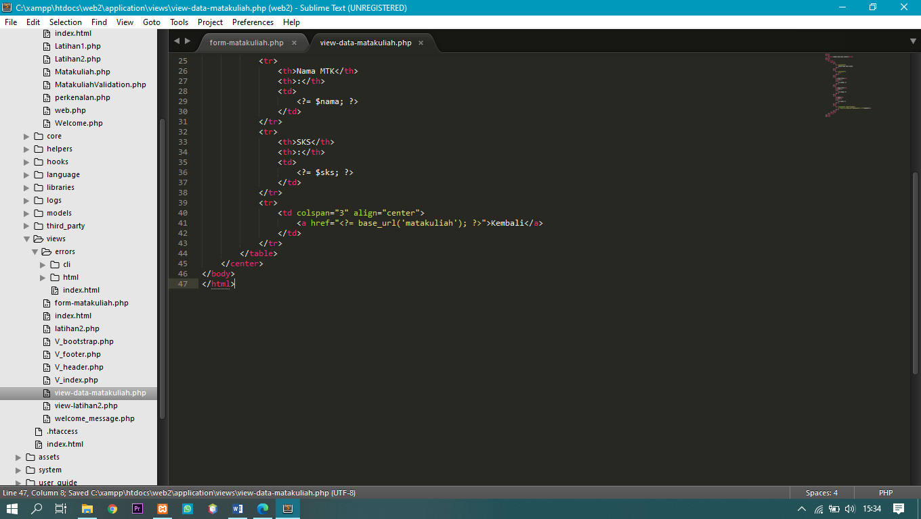

1. Screen Shoot

